Summary

Talkable has been integrated successfully and is working on following sample store:

<https://talkable01-tech-prtnr-na02-dw.demandware.net/s/SiteGenesis/home>

Each Test Case represents a different Talkable campaign.

You can control which campaigns to show on your store in Business Manager →

Merchant Tools → Site Preferences → Custom Preferences → Talkable.

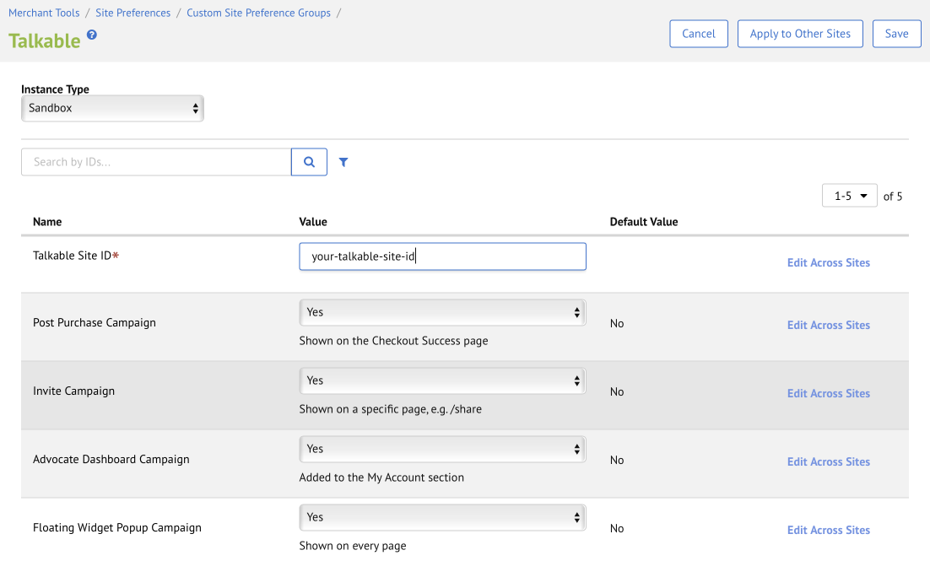

# **Test Case 1:** Floating Widget Popup Campaign

Floating Widget is displayed in the bottom left corner on all pages as per the screenshot below (except for the pages where other Talkable campaigns are shown, see the following test cases). Click on the widget opens Talkable pop-up.

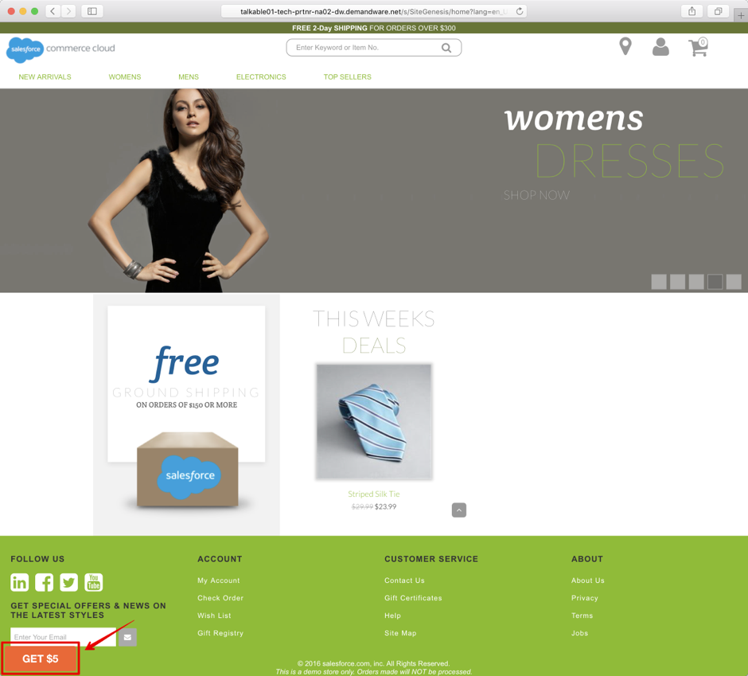

# **Test Case 2:** Post Purchase Campaign

Once the order confirmation page loads, Talkable pop-up displays.

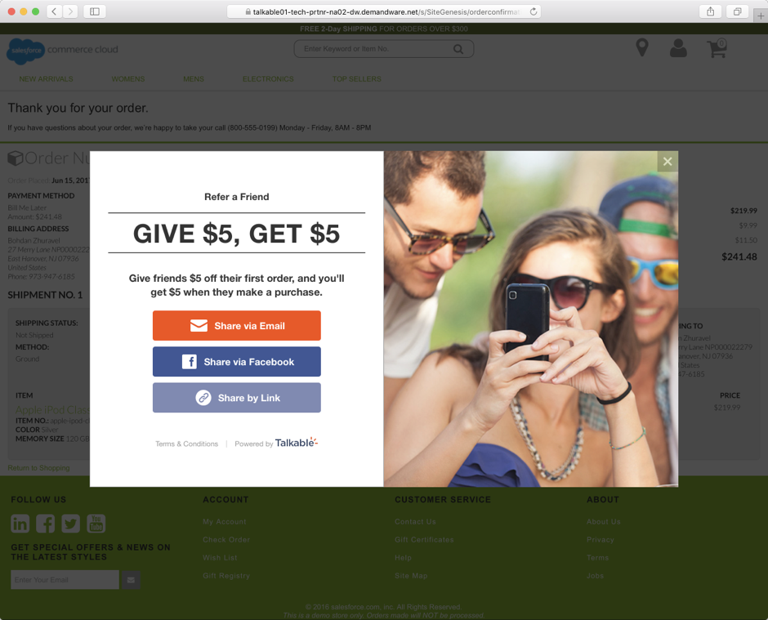

# **Test Case 3:** Invite Campaign

Open **/share** page of your store, e.g.:

[https://talkable01-tech-prtnr-na02-dw.demandware.net/s/SiteGenesis**/share**](https://talkable01-tech-prtnr-na02-dw.demandware.net/s/SiteGenesis/share)

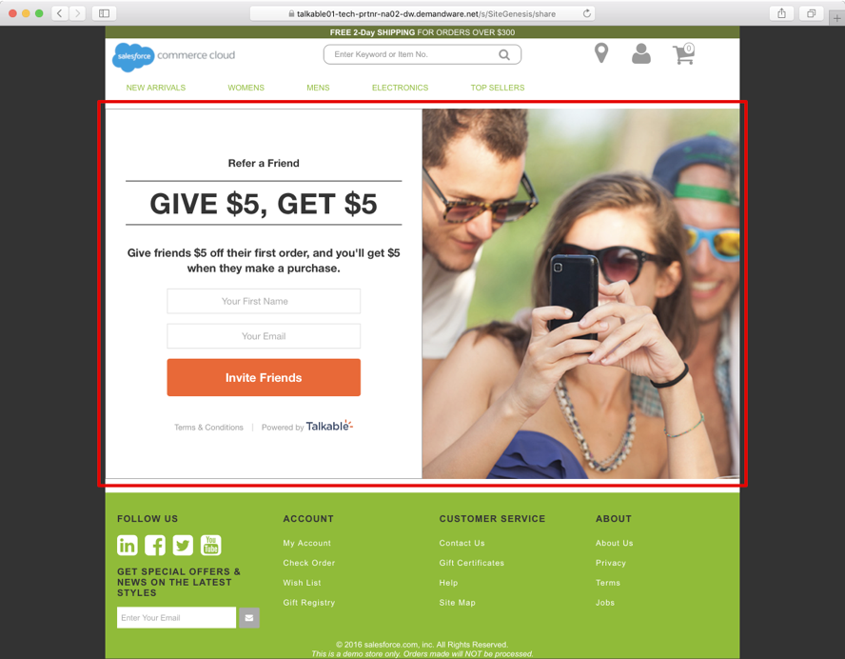

*/share* can be changed to anything else from Business Manager →

Merchant Tools → Site URLs → URL Rules → Pipeline URLs by editing the alias which resolves to *Talkable-Standalone*:

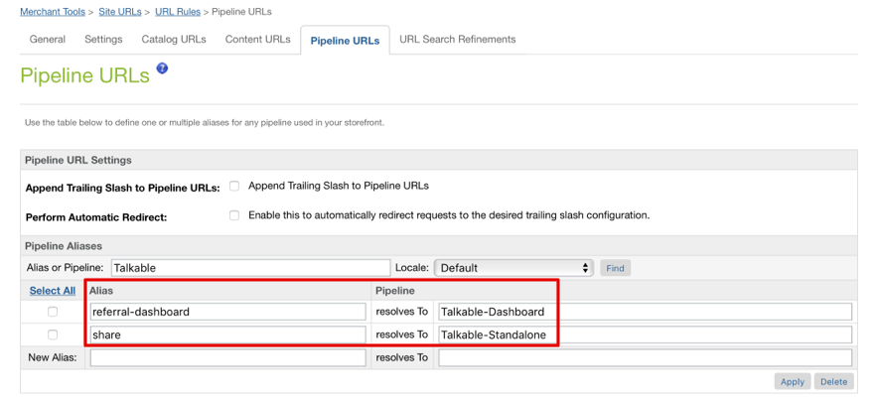

# **Test Case 4:** Advocate Dashboard Campaign

Referral Dashboard is added to the My Account section for logged-in customers.

